SWE4303 Computing Infrastructure
Week 2 | Session 2 Lab Handout
Topology Modelling and Switching Behaviour: Frame Delivery in a Controlled LAN
Cisco acknowledgement: This lab is adapted for teaching in SWE4303 using Cisco Packet Tracer and selected Cisco Networking Academy lab approaches. Cisco is acknowledged as the original source of the underlying platform and lab style used here for educational delivery.
Purpose of this lab
This lab helps you move from lecture ideas into practical local LAN/frame-delivery observation. You will build a small local area network in Cisco Packet Tracer, inspect MAC addresses, observe switch MAC learning, and then explain what the switch is doing. The handout is written so that you can work with tutor guidance in class or continue independently if needed.
What you should be able to do by the end
- build a simple LAN topology in Packet Tracer using appropriate devices and connections
- configure basic IP addressing and verify local connectivity
- identify MAC addresses on PCs and switches and recognise their 48-bit hexadecimal format
- observe how a switch builds its MAC address table after traffic is generated
- use topology, MAC addressing, and switching behaviour to explain simple LAN communication outcomes
Software and resources
- Cisco Packet Tracer installed and working
- one PC or laptop with enough screen space to view the workspace and device windows comfortably
- this handout open beside Packet Tracer if possible
- time to save work carefully after each major stage
Before you start
- Open Packet Tracer and make sure you are in Realtime mode.
- Save your file early with a clear name such as Week2_Session2_YourName.pkt.
- Save again after each major part. Do not leave all saving until the end.
- If you are working online or independently, read the full Part 0 before you start building the topology.

Cable guidance for this lab
Use the cable names shown below exactly as written.
Connection | Cable to use | Notes
PC to switch | Copper Straight-Through | Use this for each PC-to-switch link in this lab.
Switch to switch | Copper Cross-Over | Use this for the inter-switch link in Part 5.
PC to switch console access | Light blue Console cable | Use only if your tutor asks you to access a switch through Desktop > Terminal instead of the CLI tab.

Part 0 — Getting started in Packet Tracer
This part is short but important. If Packet Tracer is new to you, do not skip it.
Find the main areas of the interface
- The large white area in the middle is the workspace where you place and connect devices.
- The bottom-left area contains device categories.
- The lightning-bolt icon opens the Connections category for cables.
- PCs are found under End Devices.
- Switches are found under Network Devices > Switches.
Know where you will work inside each device
- On a PC, use the Desktop tab for IP Configuration and Command Prompt.
- On a switch, use the CLI tab to enter commands directly for this lab.
- You do not need to use a console cable in this lab unless your tutor asks you to do so.

Part 1 — Build the initial topology
In this part you will build a simple single-switch LAN. Keep the layout tidy so that you can read your own network clearly and compare it with the handout.
Devices to place
- Place 1 switch in the centre of the workspace. Name it S1. (use 2960 switch)
- Place 2 PCs and name them PC-A and PC-B. Place PC-A on the left and PC-B on the right.
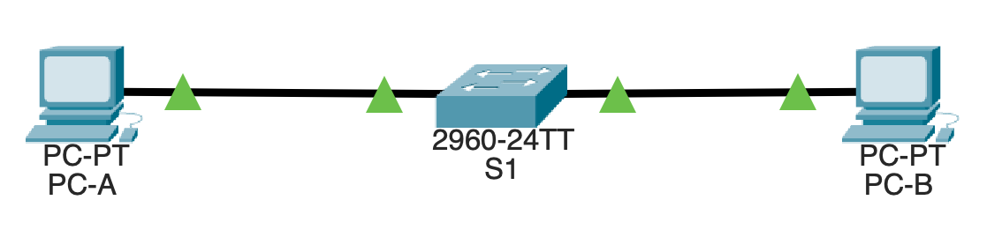
Figure 1. Initial topology to build in Packet Tracer
Connect the devices
- Connect PC-A to S1 FastEthernet0/6 using Copper Straight-Through.
- Connect PC-B to S1 FastEthernet0/18 using Copper Straight-Through.
- Save the Packet Tracer file before moving to Part 2.
Addressing table for the initial topology
Device | Interface | IPv4 address | Subnet mask
S1 | VLAN 1 | 192.168.1.11 | 255.255.255.0
PC-A | NIC | 192.168.1.1 | 255.255.255.0
PC-B | NIC | 192.168.1.2 | 255.255.255.0
Part 2 — Configure devices and verify connectivity
Configure the PCs
- Click PC-A > Desktop > IP Configuration and enter the IPv4 address and subnet mask from the table above.
- Repeat the same process for PC-B.
- Leave the default gateway blank for this lab because all devices are on the same local network.
Configure the switch
Click S1 > CLI tab and enter the following commands exactly as shown. The prompt changes as you move through configuration mode.
Switch> enable
Switch# configure terminal
Switch(config)# hostname S1
S1(config)# no ip domain-lookup
S1(config)# interface vlan 1
S1(config-if)# ip address 192.168.1.11 255.255.255.0
S1(config-if)# no shutdown
S1(config-if)# end
S1# copy running-config startup-config
If Packet Tracer asks you to confirm the save when you use copy running-config startup-config, press Enter to accept the default destination filename.
What the S1 configuration is doing
Command or command group | Why it is used
enable | Moves from basic user mode into privileged mode so that configuration commands can be used.
configure terminal | Enters global configuration mode, where device settings can be changed.
hostname S1 | Gives the switch a clear name so outputs and prompts are easier to read.
no ip domain-lookup | Prevents Packet Tracer from pausing while trying to treat mistyped commands as domain names.
interface vlan 1 | Selects the switch management interface used in this simple lab.
ip address 192.168.1.11 255.255.255.0 | Gives S1 a management IPv4 address in the local LAN.
no shutdown | Activates the VLAN 1 management interface so it can respond to management tests.
copy running-config startup-config | Saves the configuration so it is not lost if the switch restarts.
Verify the switch interface status
- On S1, enter the following command:
S1# show ip interface brief

- Check that VLAN 1 is up. If it is not up, recheck the IP configuration and confirm that you used no shutdown on the VLAN 1 interface.
Test connectivity
- On PC-A, open Desktop > Command Prompt and ping 192.168.1.2.
- On PC-A, ping 192.168.1.11.
- On PC-B, ping 192.168.1.1.
- On PC-B, ping 192.168.1.11.
- If the first ping fails, try the same ping again before deciding there is a problem.
Common troubleshooting checks at this stage
- Check that each PC is in the correct subnet: 192.168.1.x /24.
- Check that the devices are actually connected to the switch, not just placed near it.
- Check that you used Copper Straight-Through for PC-to-switch links.
- Check that the switch VLAN 1 interface has the correct IP address and has been brought up with no shutdown.
- Check that you are using the correct device window: Desktop for PCs, CLI for the switch.

Part 3 — View and interpret MAC addresses
Now that the LAN is working, inspect the MAC addresses that support local frame delivery.
View the MAC address on each PC
- On PC-A, open Command Prompt and enter ipconfig /all.
- Find the Physical Address entry and write it down.
- Repeat the same process on PC-B.
Remember that a MAC address is a 48-bit address usually shown as six pairs of hexadecimal characters. Example: 00:1A:2B:3C:4D:5E
Record what you observe
Device | Observed MAC address | First half (vendor/OUI) | Second half (device-specific part)
PC-A
PC-B
View MAC-related information on the switch
- On S1, enter the following command:
S1# show interfaces vlan 1

- Look for the hardware address shown for VLAN 1. Depending on the Packet Tracer switch model, you may also see the burned-in address (BIA).
- On S1, enter the following command:
S1# show arp

- Use the output to connect IP observations and MAC observations inside this local LAN.
Part 4 — Examine the switch MAC address table
In this part you will observe how a switch records visible source MAC addresses and links them to ports.
Check the MAC address table
- On S1, enter the following command:
S1# show mac address-table

- You may already see some entries if you have generated traffic during earlier steps.
Generate more traffic
- From PC-A, ping PC-B.
- From PC-B, ping PC-A.
- From both PCs, ping the switch management IP address 192.168.1.11.

Check the MAC address table again
- On S1, enter the same command again:
S1# show mac address-table

- Use the output to answer the questions below.
Which PC MAC addresses now appear in the table?
Answer: ________________________________________________
Which switch port is associated with each MAC address?
Answer: ________________________________________________
What changed after traffic was generated?
Answer: ________________________________________________
Why would the switch need this information?
Answer: ________________________________________________
Part 5 — Extend the LAN to two switches
This part lets you observe how switch learning behaves when communication passes through an inter-switch link.
Expanded topology
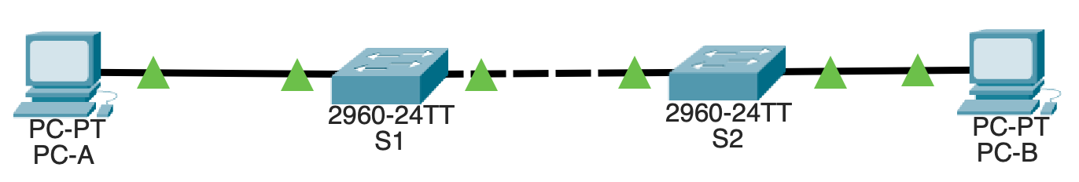
Figure 2. Expanded topology for Part 5
Add the new device and link
- Drag a second switch onto the workspace and name it S2.
- Connect S1 Fa0/1 to S2 Fa0/1 using a Copper Cross-Over cable.
- Disconnect PC-B from S1 and reconnect PC-B to S2 Fa0/18 using a Copper Straight-Through cable.
Configure S2
- On S2, enter the following commands:
Switch> enable
Switch# configure terminal
Switch(config)# hostname S2
S2(config)# no ip domain-lookup
S2(config)# interface vlan 1
S2(config-if)# ip address 192.168.1.12 255.255.255.0
S2(config-if)# no shutdown
S2(config-if)# end
S2# copy running-config startup-config
What the S2 configuration is doing
Command or command group | Why it is used
hostname S2 | Gives the second switch a clear name so it can be distinguished from S1.
no ip domain-lookup | Prevents Packet Tracer from pausing if a command is typed incorrectly.
interface vlan 1 | Selects the switch management interface for S2.
ip address 192.168.1.12 255.255.255.0 | Gives S2 a management IPv4 address in the same local LAN as the other devices.
no shutdown | Activates the VLAN 1 management interface.
copy running-config startup-config | Saves the S2 configuration so it is retained after restart.

- PC-B keeps the same IPv4 address: 192.168.1.2 / 255.255.255.0
Verify connectivity in the extended topology
- From PC-A, ping 192.168.1.2.
- From PC-B, ping 192.168.1.1.
- Ping 192.168.1.11 and 192.168.1.12 from one or both PCs.
Check MAC learning on both switches
- On both S1 and S2, enter the following command:
S1# show mac address-table
S2# show mac address-table

- Compare the outputs and answer the questions below.
Which MAC address does S1 learn through the inter-switch link?
Answer: ________________________________________________
Which MAC address does S2 learn through the inter-switch link?
Answer: ________________________________________________
Which MAC addresses are local to each switch?
Answer: ________________________________________________
How does the inter-switch link change what each switch knows?
Answer: ________________________________________________
Part 6 — From network layout to network reasoning
Use your observed outputs to explain the behaviour of the LAN.
How are devices connected in your final topology?
Answer: ________________________________________________
What is the communication path from PC-A to PC-B?
Answer: ________________________________________________

What evidence shows that switches learn where devices are located?
Answer: ________________________________________________
What would happen if the inter-switch link failed?
Answer: ________________________________________________
What would happen if S1 failed? What would happen if S2 failed?
Answer: ________________________________________________
Optional challenge — Use Simulation Mode
Complete this only if you have finished the main lab or your tutor asks you to do it.
- Switch Packet Tracer from Realtime to Simulation mode.
- Generate one ping from PC-A to PC-B.
- Use Capture / Forward to step through the process.
- Look at the source and destination MAC addresses shown on the early steps of the communication.
- Note whether the MAC addresses remain the same inside this single LAN or change.
Challenge reflection
What does Simulation Mode help you see that a simple ping does not?
Answer: ________________________________________________

Evidence checklist
Before you finish, make sure you have the following evidence.
Evidence item | Completed
Screenshot of the single-switch topology | [ ]
Screenshot of the final two-switch topology | [ ]
Screenshot or note of PC-A and PC-B IP settings | [ ]
Output from ipconfig /all on both PCs | [ ]
Output from show interfaces vlan 1 on S1 | [ ]
At least one output from show mac address-table on S1 | [ ]
At least one output from show mac address-table after the two-switch extension | [ ]
Ping evidence showing successful local communication | [ ]
Short written answers for the reasoning questions | [ ]
If you get stuck
- Read the instruction again before starting a new configuration attempt.
- Check the cable type first. Many Packet Tracer problems are simple cable or interface mistakes.
- Check the IP address and subnet mask second.
- Check the switch VLAN 1 interface third.
- Generate traffic again before expecting the MAC address table to become useful.
- Save your file before making major changes so that you can return to a working version if necessary.
Key idea from this lab
A switch does not forward traffic randomly. It learns source MAC addresses, links them to ports, and uses that information to support local frame delivery inside the LAN.
Consolidate and look ahead
After the lab, review your answers and complete the Week 2 quiz on topologies, MAC addressing, Ethernet behaviour, and switching. Keep your Packet Tracer file because it may help you revisit the Week 2 lecture ideas.

